Numpy 2 Hacker Rank
1. Task
Your task is to print an array of size X with its main diagonal elements as 's and 's everywhere else.
Note
In order to get alignment correct, please insert the line
np.set_printoptions(legacy='1.13')

below the numpy import.
Input Format
A single line containing the space separated values of and .
N denotes the rows.
M denotes the columns.
Output Format
Print the desired N X Marray.
Sample Input
3 3
Sample Output
[[ 1. 0. 0.]
[ 0. 1. 0.]
[ 0. 0. 1.]]
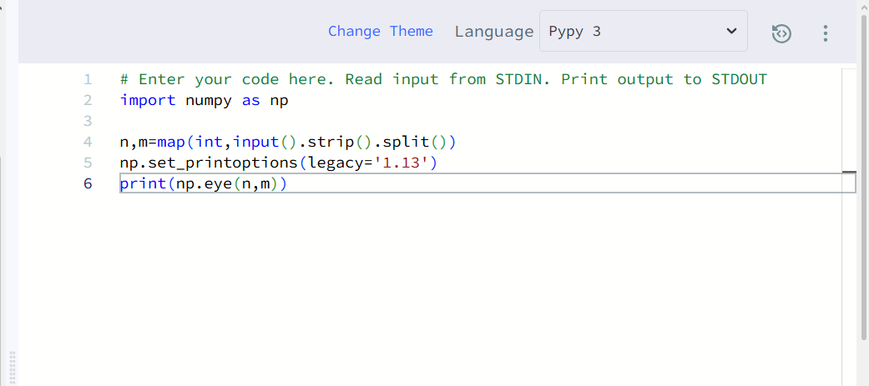
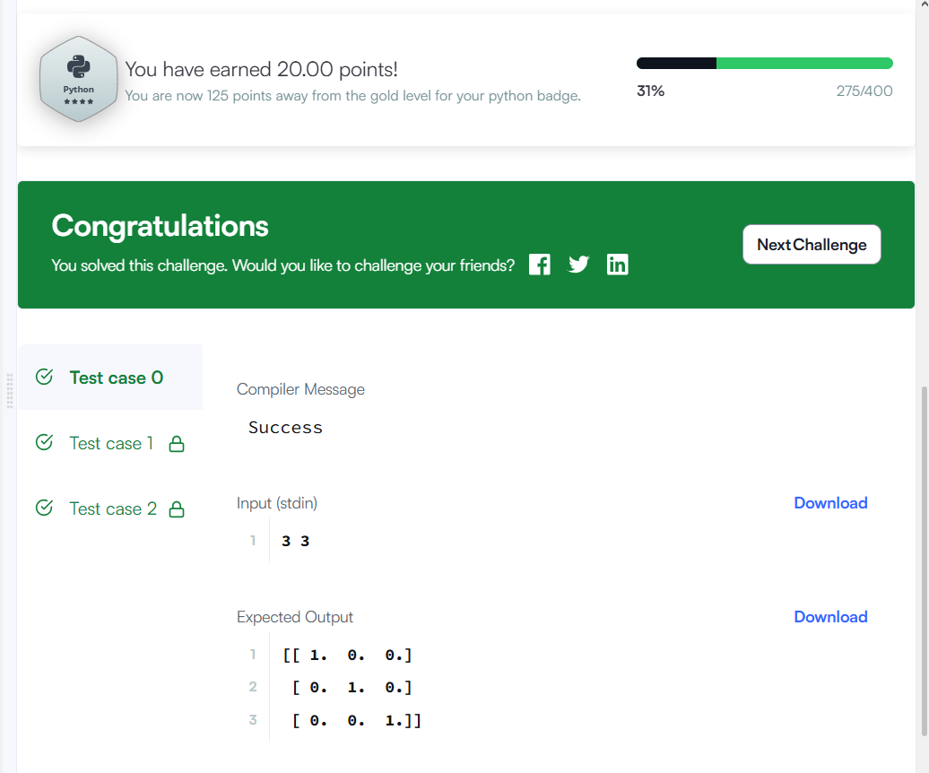

2.
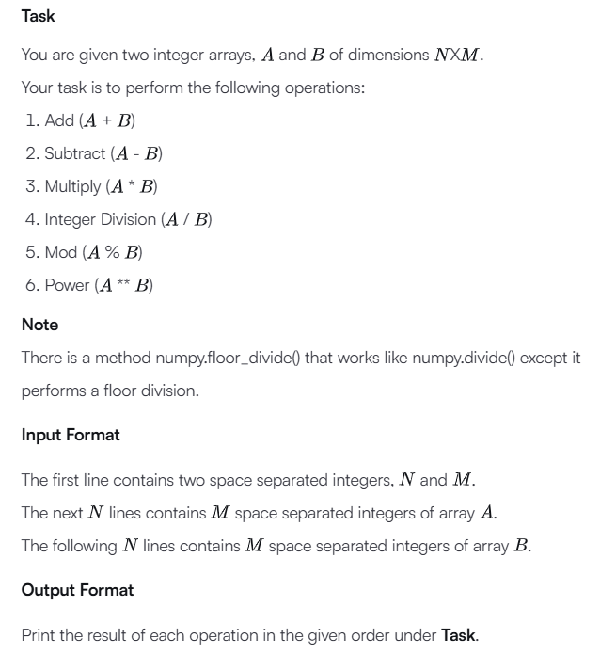

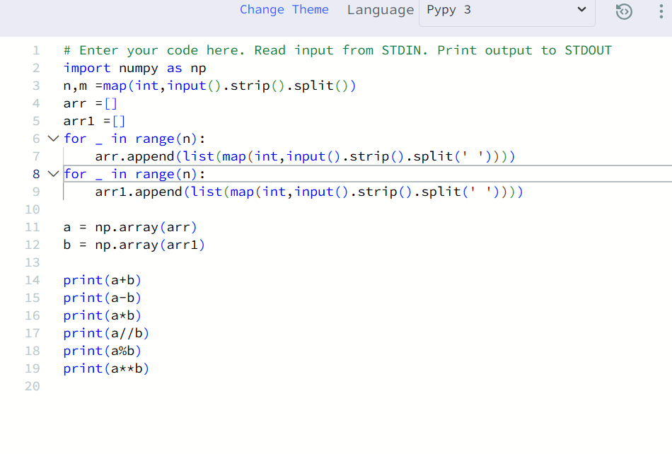
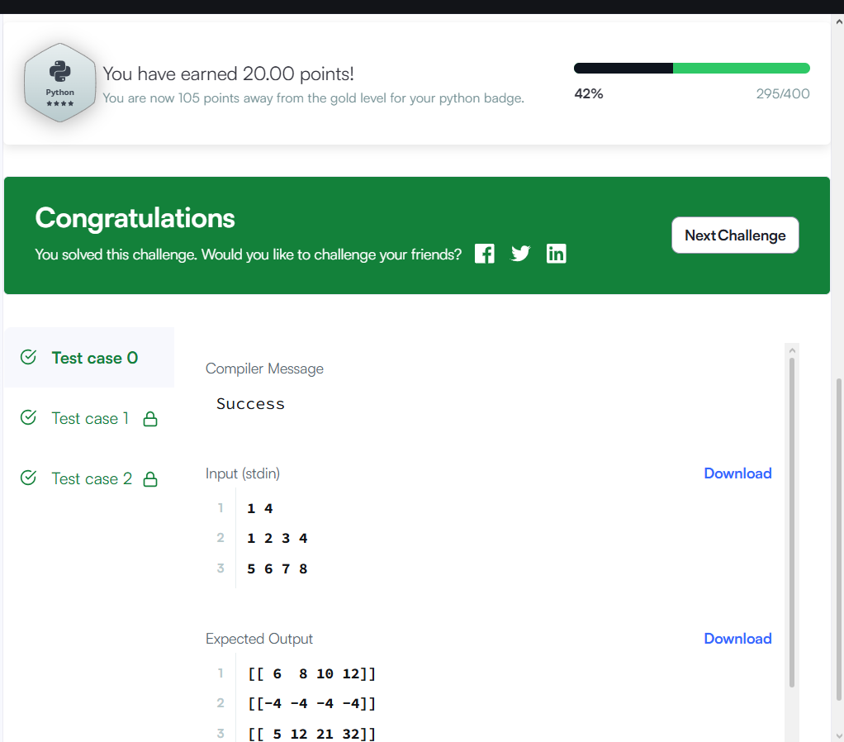

3.
